
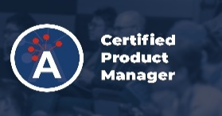
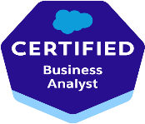
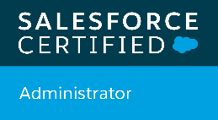
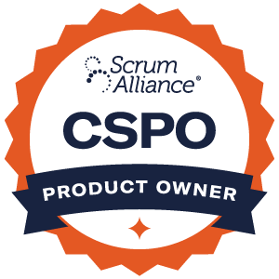
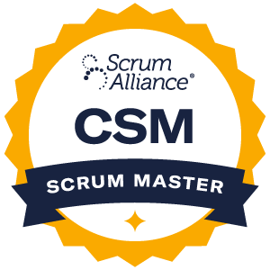
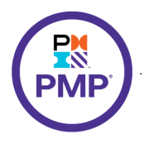
Sai Divya
Senior Business Analyst | varun@technumen.com | 732-369-9190

Professional Summary:
Senior Business Analyst with 8+ years of experience delivering enterprise CRM, data integration, and analytics solutions across Salesforce and modern data platforms. Recognized as a trusted advisor to business and technology leadership, with deep expertise in requirements elicitation, data-driven solution design, ETL coordination, and Agile delivery. Proven ability to partner with data engineering, integration, and reporting teams to shape scalable architectures, govern data flows, and support compliance-driven environments. Experienced delivering solutions in Scaled Agile (SAFe-aligned) enterprise environments, supporting PI-style planning, cross-team dependency management, and program-level delivery coordination.

Core Skills:
Business & Analysis Requirements Elicitation & Analysis | BRD / FRD | User Stories & Acceptance Criteria | Salesforce Object Mapping| Stakeholder & Executive Advisory | AS-IS / TO-BE Process Mapping | Business Process Improvement | Agile & Scrum Delivery | UAT Planning & Execution Data, Integration & Architecture Data Strategy & Governance | Source-to-Target Mapping | ETL Requirements & Validation | Data Quality & Reconciliation | API & System Integration Requirements (REST / Batch / SOAP)Risk, Dependency & Scope Management | Scaled Agile (SAFe-aligned) Delivery | PI Planning | Program-level Coordination Platforms & Tools Salesforce (Sales, Education, Marketing, Data, Service Cloud) | Workday | Snowflake | SQL Server | Tableau | Power BI | Jira | Confluence | Azure DevOps | Lucid chart | Miro

Certifications:
Project Management Professional (PMP) – PMI | Certified ScrumMaster (CSM) – Scrum Alliance | Certified Scrum Product Owner (CSPO) – Scrum Alliance | Salesforce Certified Administrator |Salesforce Certified Business Analyst |Certified Product Manager – Product Alliance. | SAFe Product Owner / Product Manager (POPM)

Professional Experience:

Senior Business Systems Analyst

Client: Louisiana State University | June 2024 – Present
- Lead end-to-end business analysis and solution discovery for enterprise Salesforce CRM, data integration, and analytics initiatives, shaping platform direction, delivery priorities, and data strategy.
- Facilitate stakeholder interviews and JAD workshops to clarify ambiguous requirements and align business, compliance, and technical stakeholders.
- Translate business needs into user stories, functional specifications, acceptance criteria, and data mappings
- for cross-functional Agile teams.
- Partner with data engineering teams to define ETL/ELT requirements, ingestion patterns, scheduling dependencies, and reconciliation rules across Salesforce, Snowflake, and reporting platforms.
- Collaborate with integration teams on API and batch integrations, documenting data contracts, transformation logic, and error-handling requirements.
- Advise leadership on solution trade-offs and data architecture impacts, ensuring scalability, governance etc
- Analyze Salesforce data models, APIs, and integration touchpoints to ensure data consistency, security, and compliance readiness.
- Define UAT strategy, coordinate testing cycles, validate functional and data accuracy prior to release.

Business Systems Analyst
Louisiana State University | Nov 2021 – Jun 2024
- Served as a senior business analysis partner across Salesforce platform modernization, data integration, and analytics initiatives.
- Led requirements discovery and full cycle project for Classic to Lightning and HEDA to Education Cloud migrations, ensuring continuity and data integrity.
- Developed AS-IS / TO-BE process models to identify gaps, risks, and opportunities across CRM, marketing automation, and reporting workflows.
- Partnered with data engineering teams to influence Snowflake data models, reporting views, data access controls, and consumption patterns.
- Supported Workday-to-Salesforce integrations, defining transformation rules, validation logic, and reconciliation checkpoints.
- Coordinated cross-functional delivery across CRM, data, marketing automation, and reporting teams.
- Lead Agile ceremonies, maintained RAID logs, test scripts, and traceability documentation.
- Delivered executive dashboards and KPI definitions to support data-driven decision-making and operational oversight.
- Recognized as a go-to analyst for complex, cross-system initiatives involving CRM, ETL, and analytics.

Product Management Analyst
Sea-Land Chemical Company | Jan 2021 – May 2021
- Translated business and product requirements into data architecture, ETL, and analytical solution requirements, data validation etc.
- Partnered with data teams to define data flows, transformations, aggregation logic, and reporting layers.
- Built Tableau dashboards and analytical models to evaluate performance, growth and operational efficiency.
- Applied Lean and Scrum practices improving delivery flow and stakeholder satisfaction.
- Supported leadership presentations with data-backed insights and performance metrics.

IT Management Analyst
Cleveland State University | Feb 2020 – Dec 2020
- Supported Agile initiatives through stakeholder analysis, feature prioritization, and sprint planning.
- Developed UML diagrams, use cases, and AS-IS / TO-BE process flows using BPMN techniques.
- Collaborated with technical and data teams to document reporting and analytics requirements.
- Customized Jira reports to track project status, risks, and delivery metrics.
- Facilitated weekly status meetings and requirement-gathering sessions.
- Supported governance and documentation of academic and operational systems.

Business Analyst.
MIM Essay | 2019 – 2020
- Led requirements gathering and process analysis for a digital content and customer management platform,
- Translated business needs into functional requirements, data definitions, and reporting specifications.
- Collaborated with developers to define data capture, validation rules, and backend system behavior.
- Supported CRM-style data management, including customer records, order tracking, and operational reporting.
- Validated delivered features through UAT, ensuring alignment with business requirements and data accuracy.

Business Analyst Gifteria | 2018 – 2019
- Gathered and documented requirements for an e-commerce platform, covering product catalog, orders, payments, and fulfillment.
- Mapped end-to-end user journeys and system data flows across front-end and backend components.
- Worked with engineering teams to define integration touchpoints (payment gateways, order processing, notifications).
- Defined data structures, transformation rules, and reconciliation checks for transactional accuracy.
- Supported reporting needs by defining sales and operational metrics for business stakeholders.

Education:
- Master’s in information systems & business Analytics.
- Bachelor’s in computer science.

